**SPI protocol**

* We use serial communication in embedded systems to transfer data from one electronic device to other
* It stands for serial peripheral interface
* It mostly used interface between microcontroller and peripherals such as sensors, ADCs, DACs, shift registers and many more
* It is synchronous type of communication protocol , in this all the devices who are communicating with each other have the same clock
* It is very fast communication protocol which works with high speed of 8Mbps or even more than that and supports high frequency clocks as well
* It is a full duplex communication protocol having master and slave configuration
* In this configuration the 2 devices talking to each other can transmit and receive data at same time
* It has two data lines
* A master can communicate with more than one slave
* Usually, the SPI is connected to external devices through four pins:

**• MISO:** Master In / Slave Out data. This pin can be used to transmit data in slave mode and receive data in master mode.

**• MOSI:** Master Out / Slave In data. This pin can be used to transmit data in master mode and receive data in slave mode.

**• SCK:** Serial Clock output for SPI masters and input for SPI slaves.

**• NSS:** Slave select. This is an optional pin to select a slave device. This pin acts as a ‘chip select’ to let the SPI master communicate with slaves individually and to avoid contention on the data lines. Slave NSS inputs can be driven by standard IO ports on the master device.

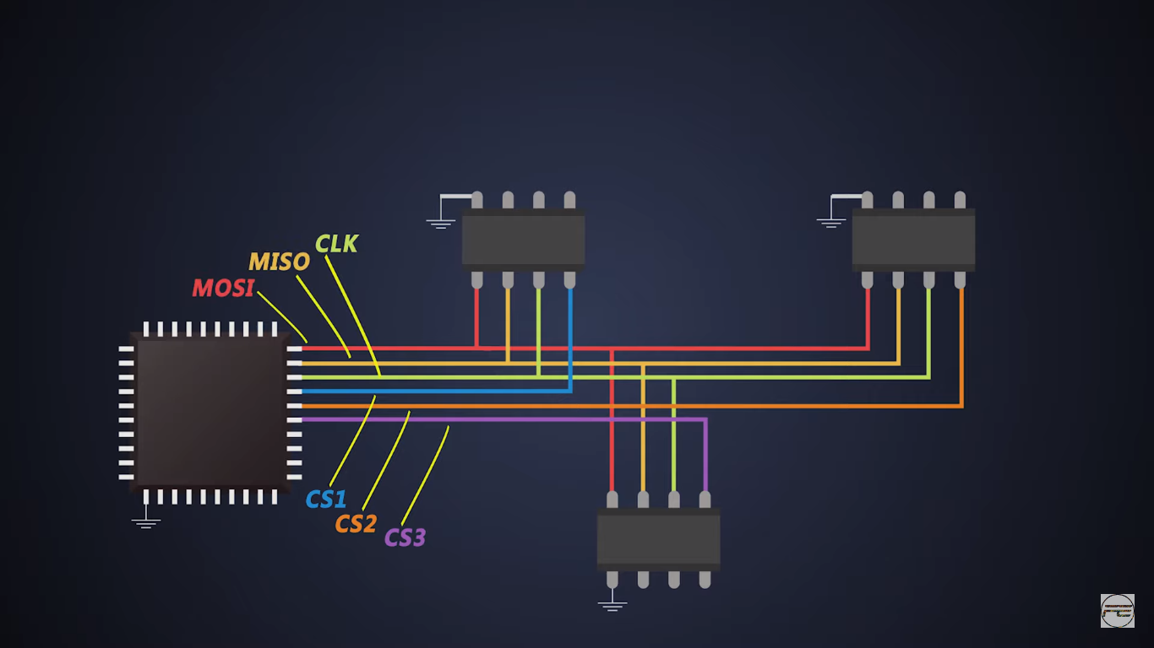

* The chip select line is an active low signal , generally it is pulled high at Vcc level when master a slave are not communicating with each other
* When master want to communicate with particular slave it will pull the clock select to ground which notifies the particular receiver that the master wants to send the data

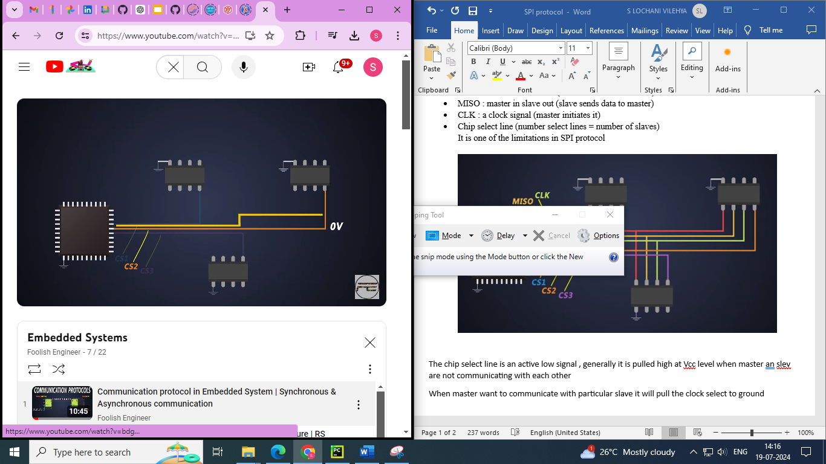

* SPI is a defactor standard protocol means it has not particular bit frame like I2C and UART . So it becomes easy to send and receive data

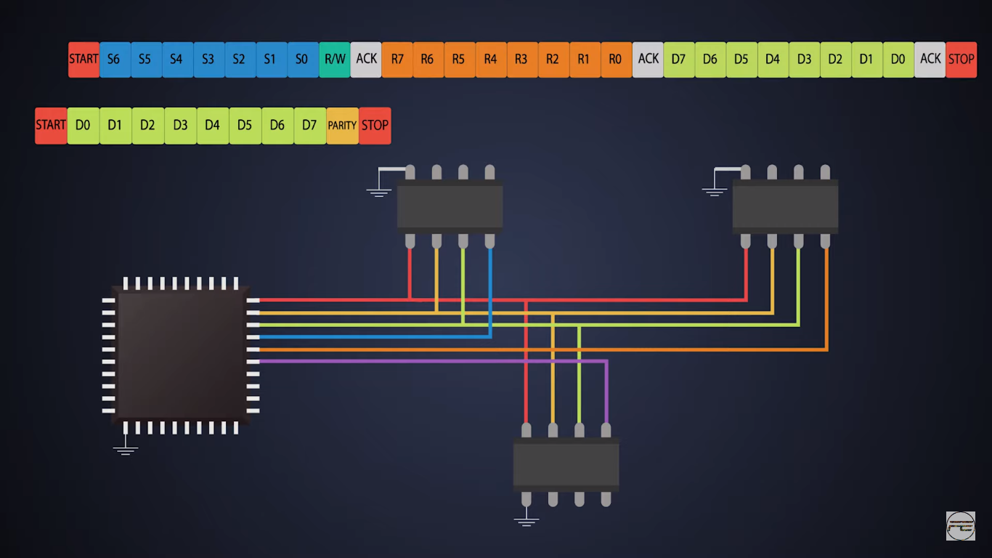

**Modes of SPI**

The four SPI modes (Mode 0, Mode 1, Mode 2, and Mode 3) determine when data is sampled relative to the clock signal. Each mode is defined by two parameters: Clock Polarity (CPOL) and Clock Phase (CPHA).

Clock Polarity (CPOL) and Clock Phase (CPHA) are two critical settings in SPI (Serial Peripheral Interface) communication that define the timing relationship between the clock signal and the data signal. These settings determine how data is transmitted and received between the master and slave devices

* **CPOL** determines the idle state of the clock signal.
* **CPHA** determines which clock edge data is sampled on and which edge it changes on.

**Clock Polarity (CPOL)**

Clock Polarity defines the idle state of the clock signal when no data is being transmitted.

* **CPOL = 0**: The clock signal is low when idle.
* **CPOL = 1**: The clock signal is high when idle.

**Clock Phase (CPHA)**

Clock Phase defines which clock edge the data is sampled on and which clock edge data changes.

* **CPHA = 0**: Data is sampled on the leading edge (the first transition) of the clock pulse and changes on the trailing edge.
* **CPHA = 1**: Data is sampled on the trailing edge (the second transition) of the clock pulse and changes on the leading edge.

The combination of CPOL and CPHA settings results in four different SPI modes:

1. Mode 0 (CPOL = 0, CPHA = 0)
2. Mode 1 (CPOL = 0, CPHA = 1)
3. Mode 2 (CPOL = 1, CPHA = 0)
4. Mode 3 (CPOL = 1, CPHA = 1)

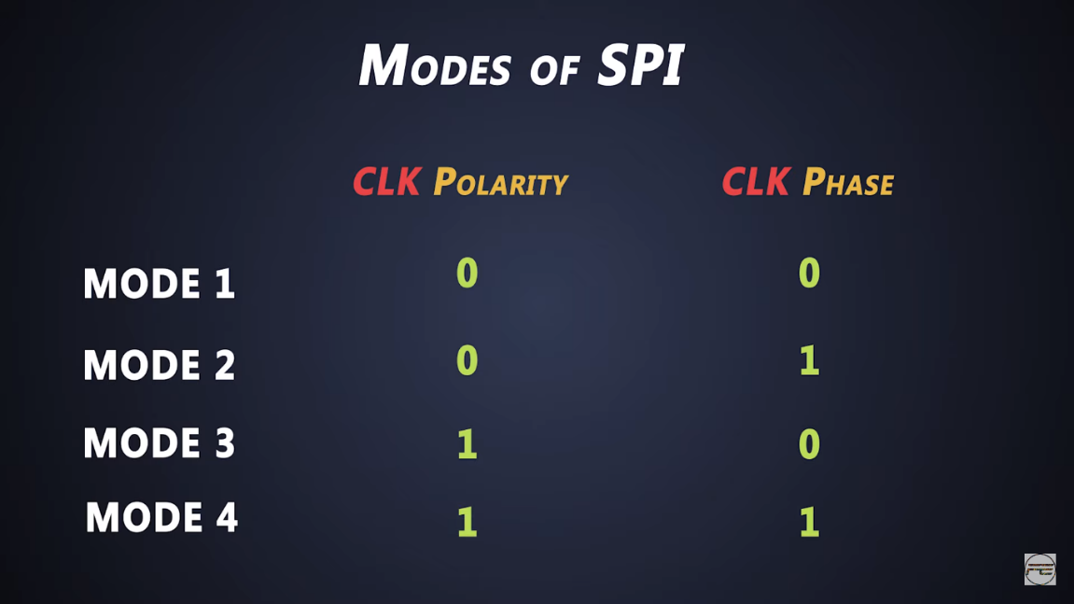

**SPI Modes Explained**

**Mode 0 (CPOL=0, CPHA=0)**

* Clock Idle State: Low
* Data Sampled On: Rising edge (leading edge)
* Data Output On: Falling edge
* Data is sampled on the rising edge of the clock, which is the first edge after the clock transition from low to high.
* Data changes on the falling edge of the clock

**Mode 1 (CPOL=0, CPHA=1)**

* Clock Idle State: Low
* Data Sampled On: Falling edge (trailing edge)
* Data Output On: Rising edge
* Data is sampled on the falling edge of the clock, which is the second edge after the clock transition from low to high.
* Data changes on the rising edge of the clock.

**Mode 2 (CPOL=1, CPHA=0)**

* Clock Idle State: High
* Data Sampled On: Falling edge (leading edge)
* Data Output On: Rising edge
* Data is sampled on the falling edge of the clock, which is the first edge after the clock transition from high to low.
* Data changes on the rising edge of the clock.

**Mode 3 (CPOL=1, CPHA=1)**

* Clock Idle State: High
* Data Sampled On: Rising edge (trailing edge)
* Data Output On: Falling edge
* Data is sampled on the rising edge of the clock, which is the second edge after the clock transition from high to low.
* Data changes on the falling edge of the clock.

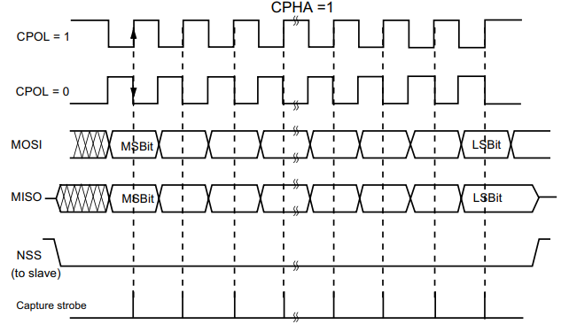

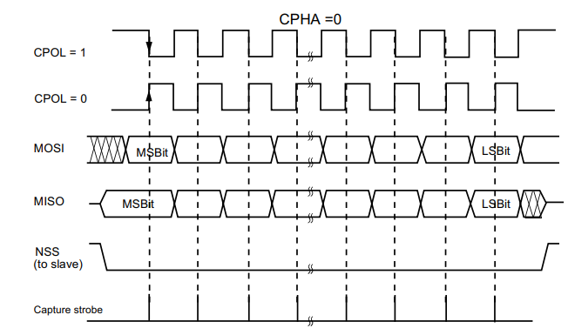

**SPI communication Data Transmission**

* There are shift registers in both master and slave
* The master and slave are connected in such a way that the two shift registers form a inter service circular buffer

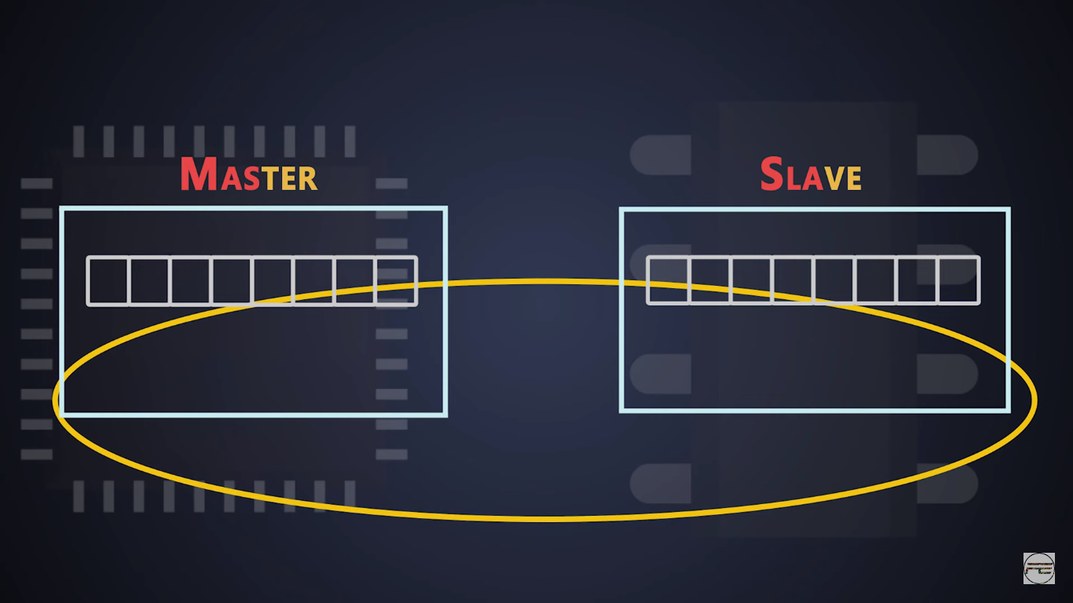

* These shift registers operate in serial in serial out mode
* The output of the master is connected to slave shift register and output of slave shift register is connected to input of master shift register .This make the connections which operate in loop
* The link which is connecting the output of master shift register to input of slave shift register is called MOSI line
* The link which is connecting the output of slave shift register to input of master shift register is called MISO line
* As it is synchronous protocol there will be a clock signal for both master and slave for synchronization and master generates this clock to get the control of the communication

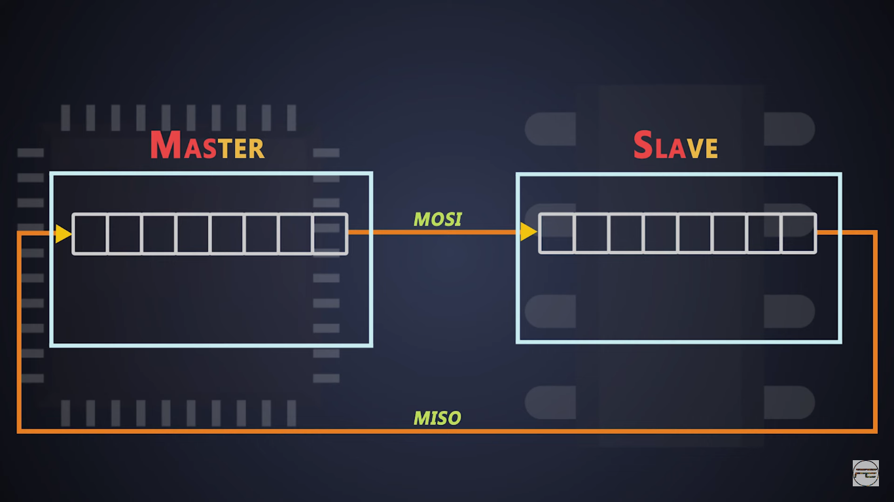

**How data is transferred from master to slave?**

* Let us imagine the data in master shift register is r7 to r0 and data in slave shift register is d7 to d0 , where d7 and r7 are MSBs of data and r0 and d0 are LSBs of data

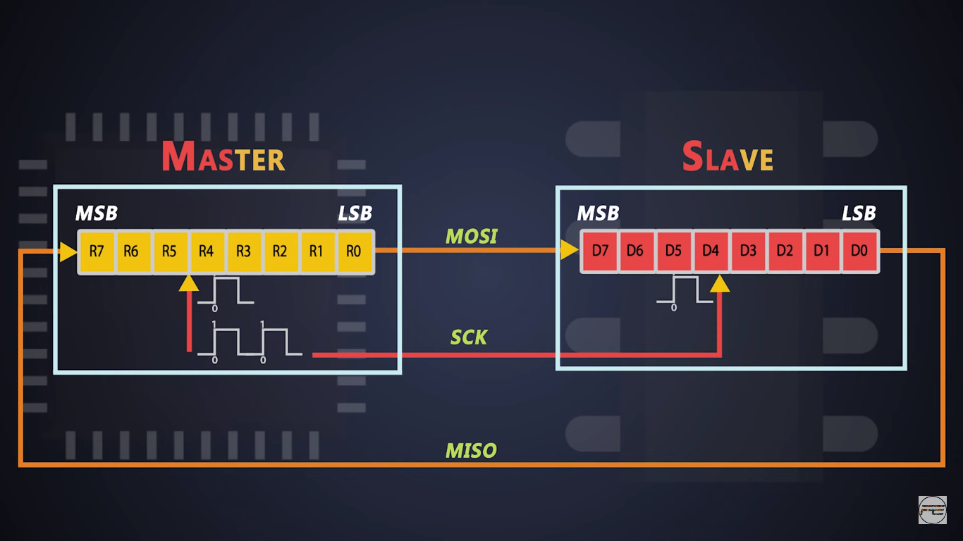

* Master initiates the communication by generating the clock pulse
* As soon as clock pulse starts shift registers from both devices shift the first bit that is master shift r0 and slave shifts d0 to right
* The master and slave are connected in ring so the ejected r0 bit is stored in MSB position of slave shift register and d0 bit is stored in MSB position of master shift register at the same time

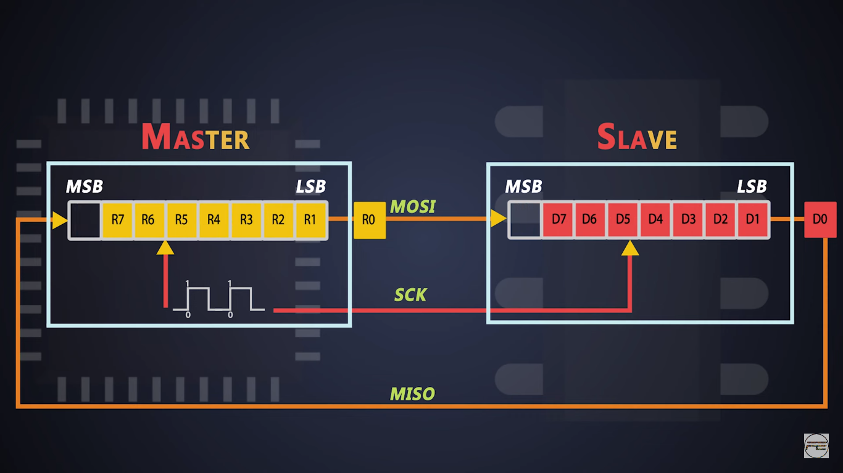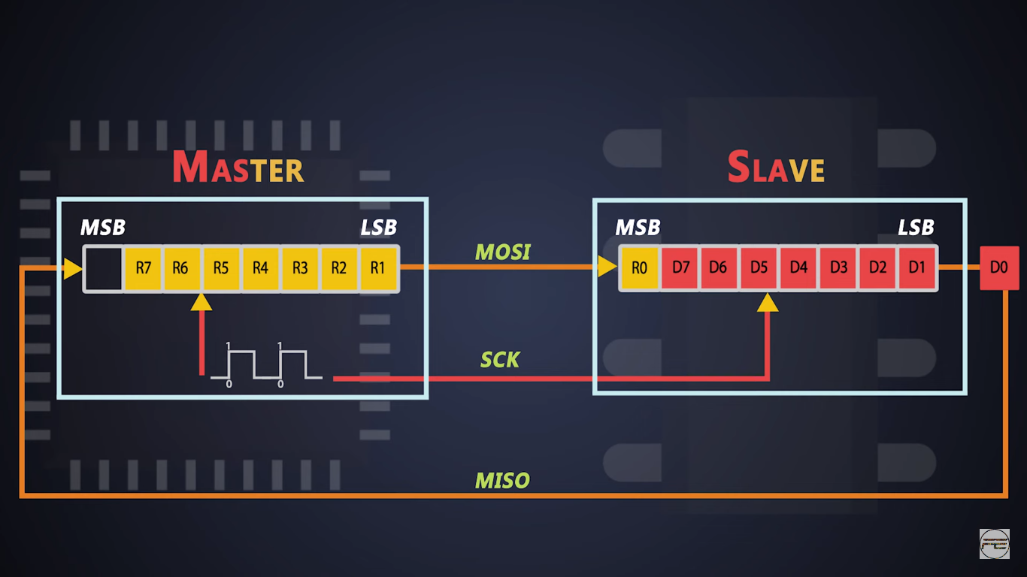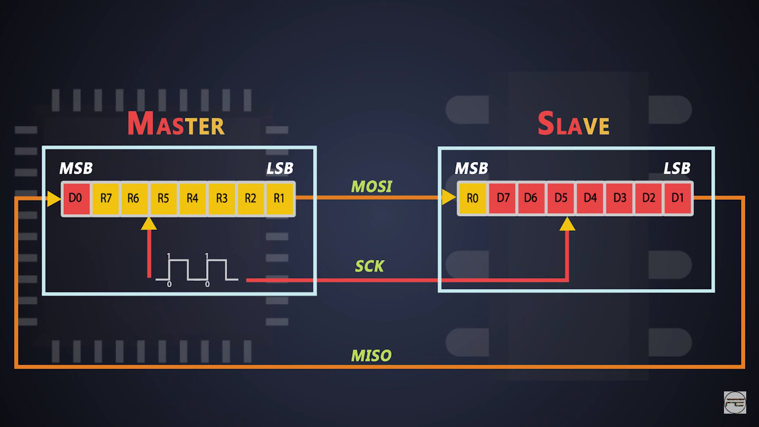

* When the master generates the next clock pulse the preceding bits get shifted from master to slave and vice versa .Thats how each bit travel from MOSI and MISO line in the SPI communication protocol

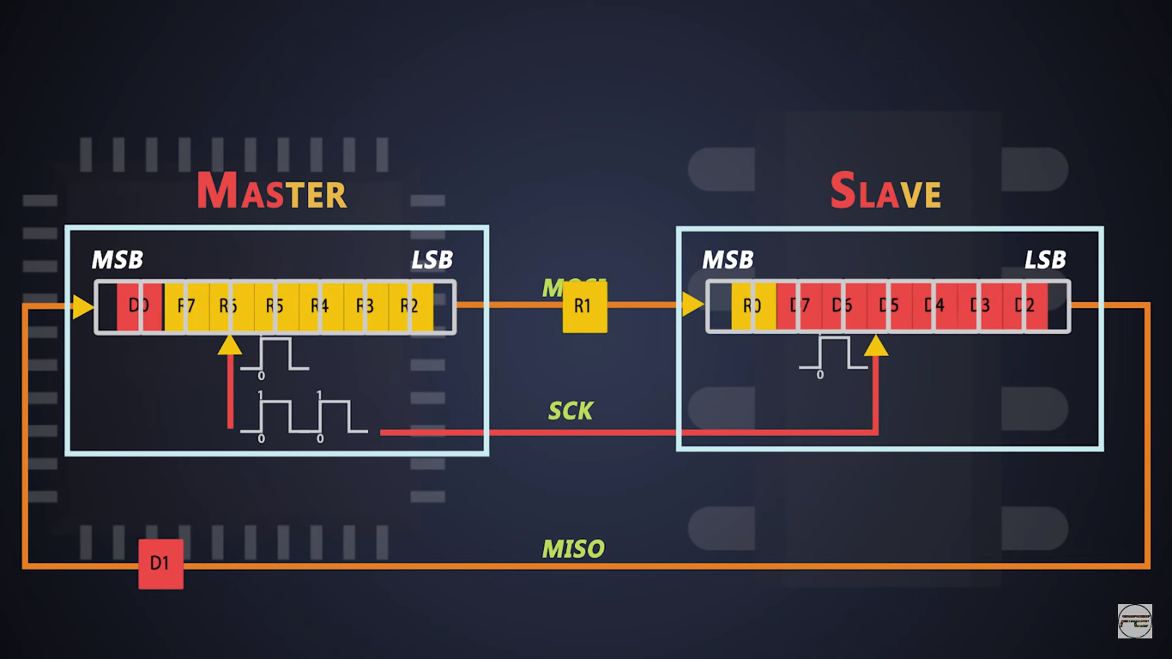

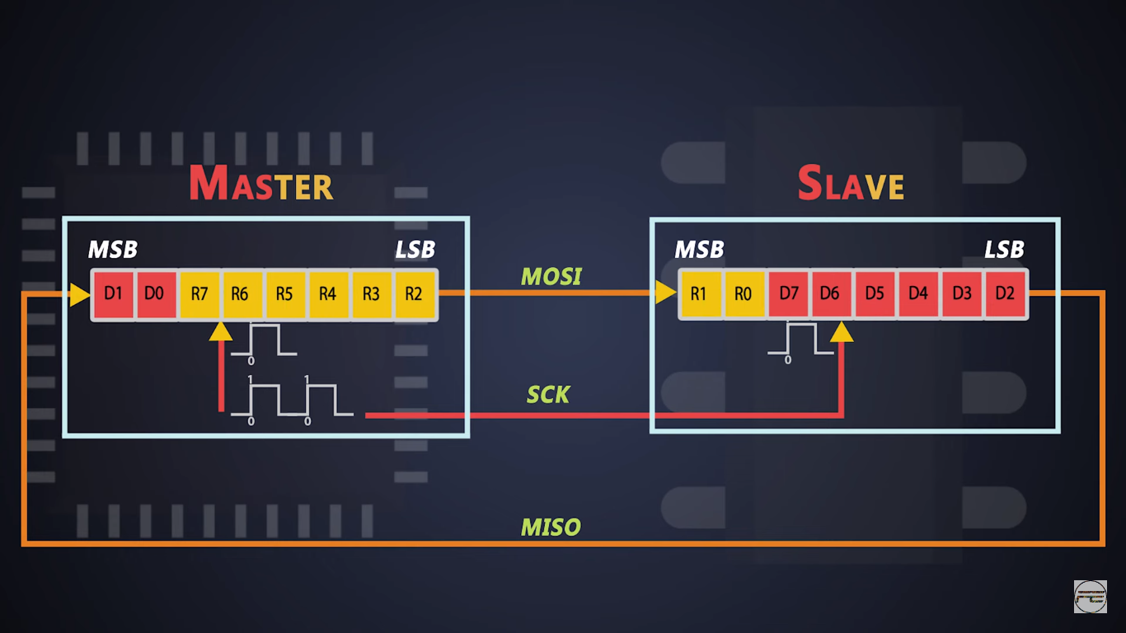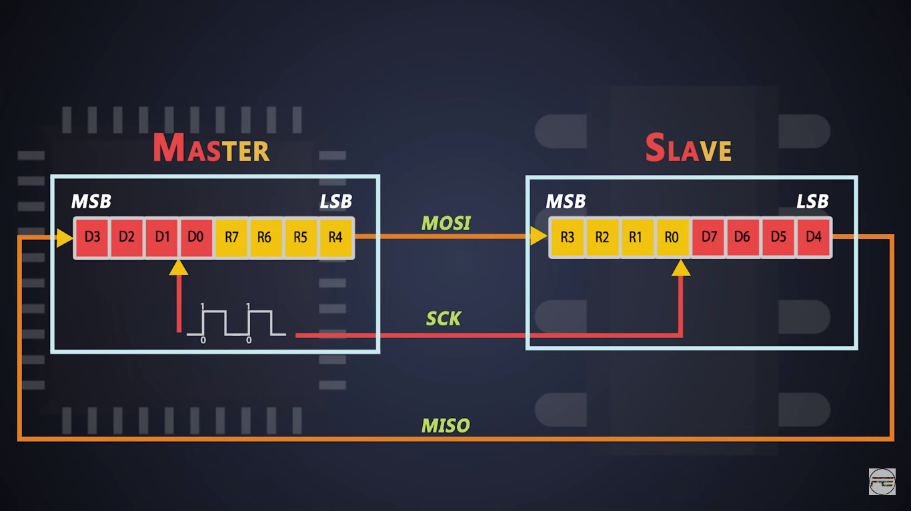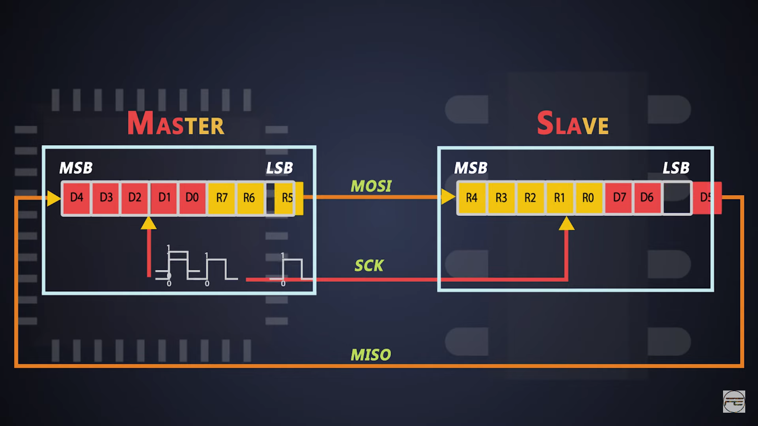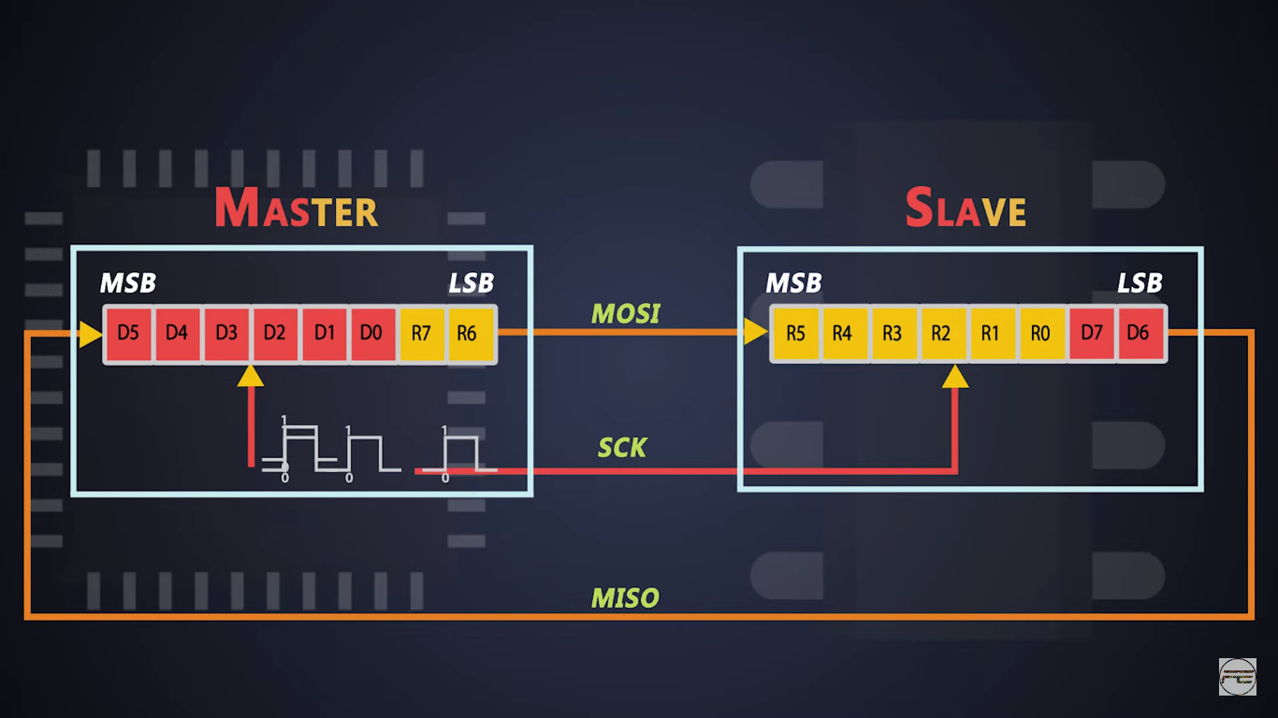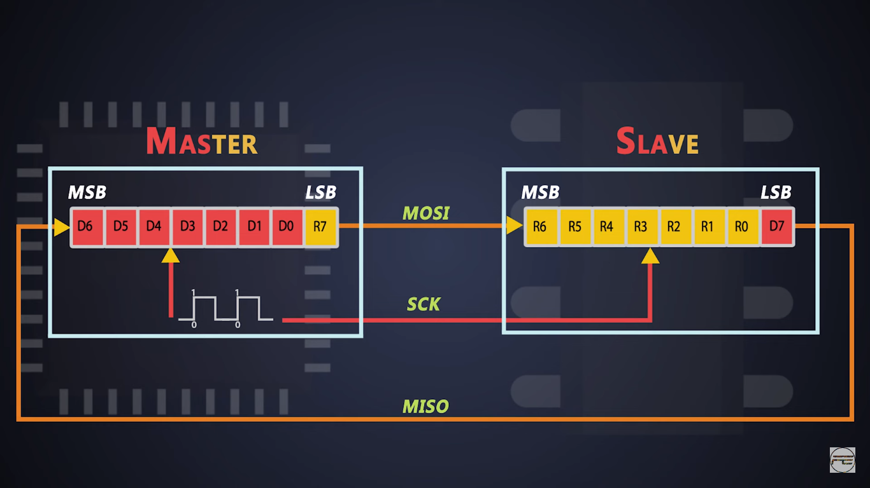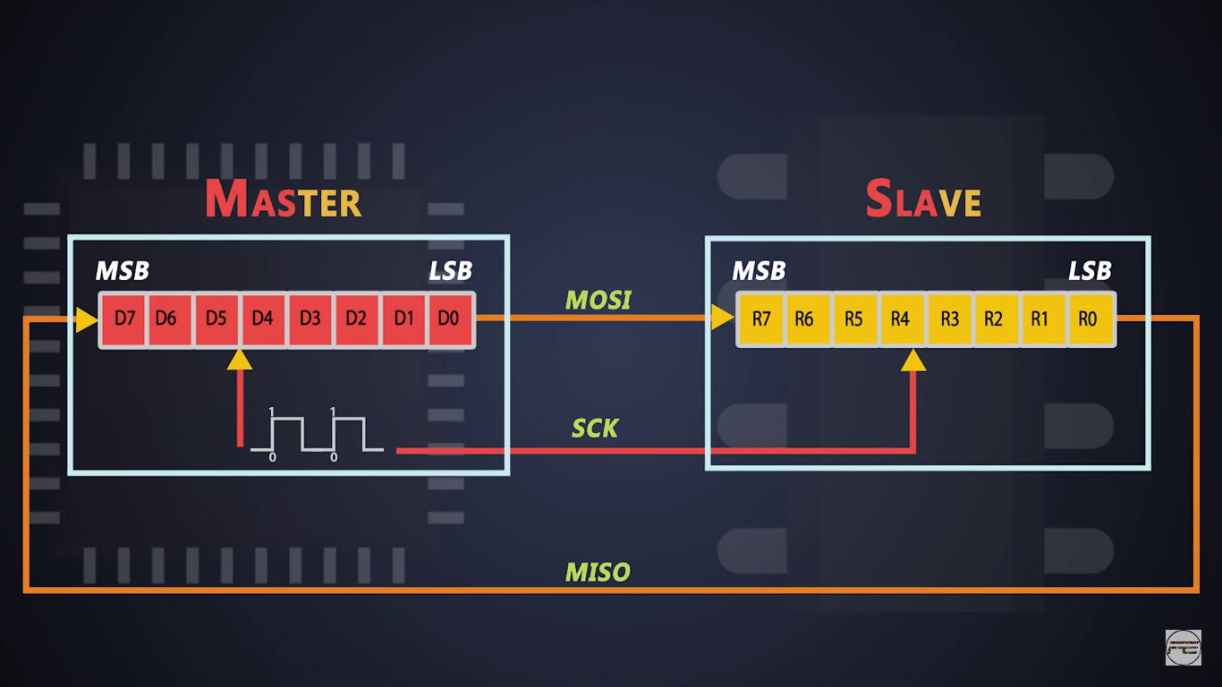

**Daisy Chain Method**

* In this protocol each slave needs a dedicated chip select line but this can be eliminated by using **“Daisy chain method”**
* One chip select line is connected to al the SPI slaves
* The daisy chain method in SPI (Serial Peripheral Interface) communication is a way to connect multiple slave devices in series rather than the traditional parallel configuration. In a daisy chain configuration, the output of one slave device is connected to the input of the next slave device in the chain. This method can simplify wiring and save GPIO pins, but it also introduces specific timing considerations and constraints.
* In a traditional SPI setup, each slave device is connected directly to the master device. The master provides separate chip select (CS) lines for each slave to enable communication with only one slave at a time.
* n a daisy chain configuration, multiple slave devices are connected in series. The SPI clock (SCK) and chip select (CS) lines are shared among all the slave devices, but the data lines (MOSI and MISO) are connected in a chain:
  + **MOSI** (Master Out Slave In) from the master connects to the **MOSI** input of the first slave.
  + **MISO** (Master In Slave Out) output of the first slave connects to the **MOSI** input of the second slave, and so on.
  + The **MISO** output of the last slave connects back to the master's **MISO** input.

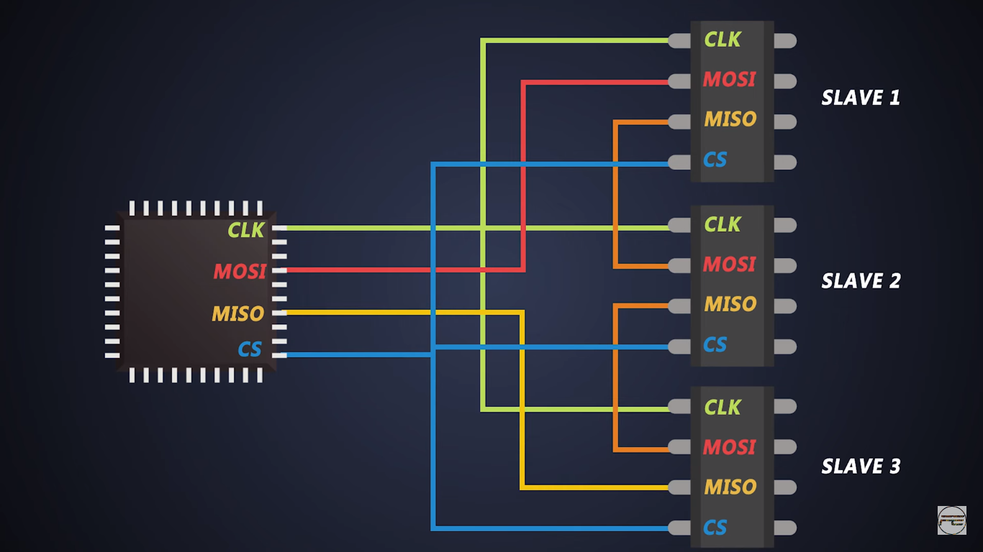

* In a daisy chain SPI configuration, the master device needs to send a continuous stream of data that passes through each slave in the chain. Each slave device processes part of this stream and then forwards the remaining bits to the next slave. Therefore, the master must send a sufficient number of bits to ensure that each slave receives and processes its expected amount of data.

**Data Flow in Daisy Chain**

* When the master sends data, it sends a continuous stream of bits.
* The data propagates through each slave in the chain.
* Each slave shifts the received bits out to the next slave on every clock pulse.
* After the entire chain receives the data, the data that was at the input of the first slave is now at the output of the last slave and can be read by the master.

**Timing Considerations**

* **Propagation Delay**: Each slave adds a small delay as it processes and forwards the data. This can affect the overall speed and timing of the communication.
* **Data Length**: The master must send enough bits to accommodate the entire chain. For example, if there are three slaves, and each slave expects 8 bits, the master needs to send 24 bits in total.

**Advantages**

* **Reduced Number of CS Lines**: Only one chip select line is needed, regardless of the number of slaves.
* **Simplified Wiring**: Fewer connections are needed, which can simplify the circuit design.

**Disadvantages**

* **Increased Propagation Delay**: Each slave introduces a delay, which can affect the maximum communication speed.
* **Complex Timing**: The master must handle the timing to ensure data integrity across all slaves.

**Detailed Explanation with Example**

Consider a scenario with three slaves (Slave 1, Slave 2, and Slave 3), and each slave is configured to process 8 bits of data. Here’s how the data flow works in a daisy chain setup:

**Initial Setup**

* **Master**: The master device sends a continuous stream of data bits.
* **Slave 1**: The first slave in the chain.
* **Slave 2**: The second slave in the chain.
* **Slave 3**: The last slave in the chain.

**Data Transmission Process**

1. **Master Sends Data**
   * The master sends a total of 24 bits of data in one continuous stream.
   * These 24 bits are intended to be processed by all three slaves.
2. **First 8 Bits Reached Slave 1**
   * The first 8 bits are received by Slave 1.
   * Slave 1 processes these 8 bits and shifts out any previous bits to Slave 2.
3. **Next 8 Bits Reached Slave 2**
   * The next 8 bits, along with the 8 bits forwarded by Slave 1, are received by Slave 2.
   * Slave 2 processes its own 8 bits and shifts out the remaining bits to Slave 3.
4. **Last 8 Bits Reached Slave 3**
   * The last 8 bits, along with the bits forwarded by Slave 2, are received by Slave 3.
   * Slave 3 processes its own 8 bits.
5. **Master Reads Data**
   * After all 24 bits are sent, the master reads the output from the last slave in the chain, which would be a combination of processed and unprocessed bits depending on the configuration and data forwarding mechanism of each slave.

**Data Example**

Assume the master needs to send data to three slaves where each expects 8 bits. Here is how the data can be visualized:

* **Master Data Stream**: 10101010 11001100 11110000

**Slave 1 Processing**

* **Receives**: 10101010
* **Processes**: 10101010
* **Forwards**: 11001100 11110000

**Slave 2 Processing**

* **Receives**: 11001100 11110000 (first 8 bits are from the master, the next bits are forwarded by Slave 1)
* **Processes**: 11001100
* **Forwards**: 11110000

**Slave 3 Processing**

* **Receives**: 11110000 (forwarded by Slave 2)
* **Processes**: 11110000

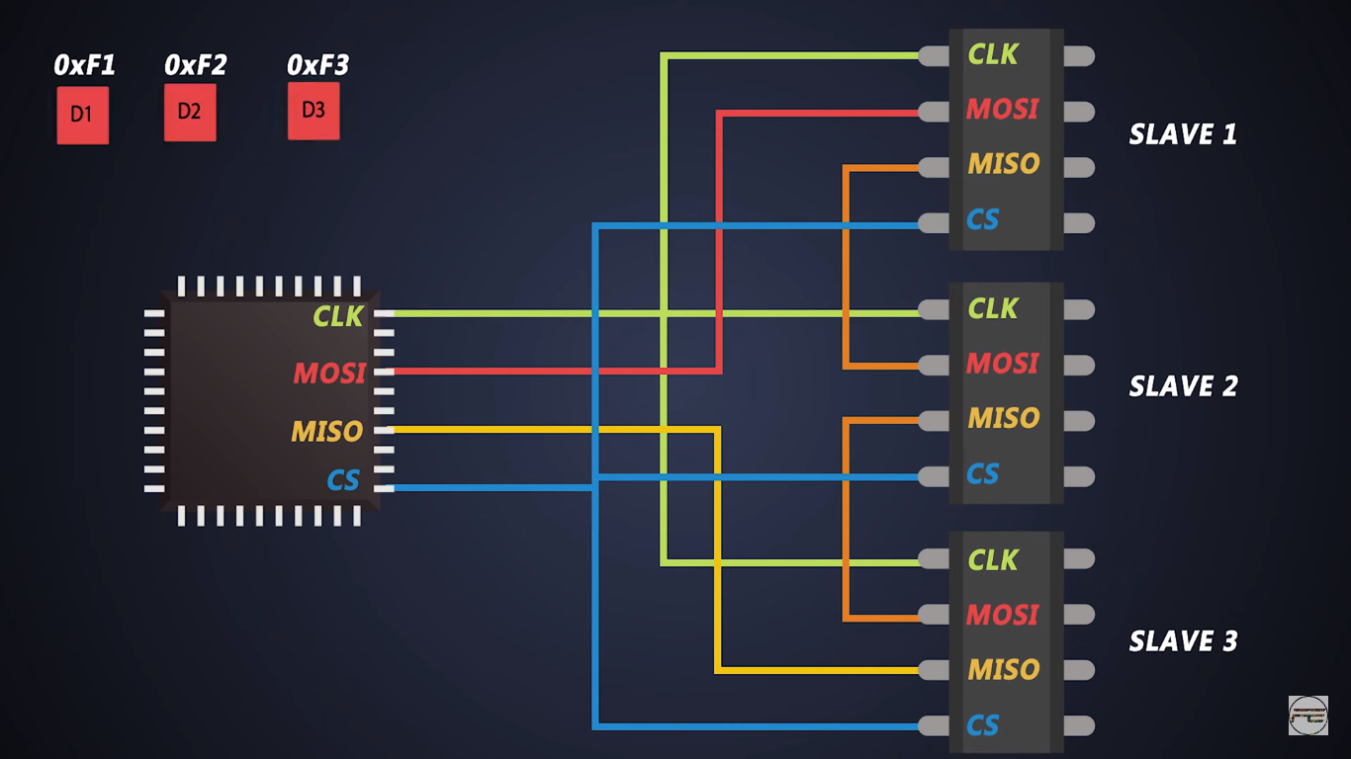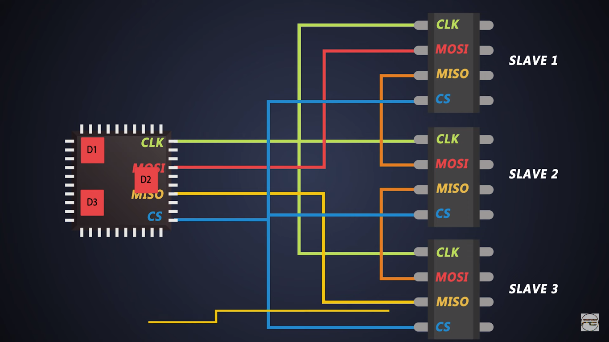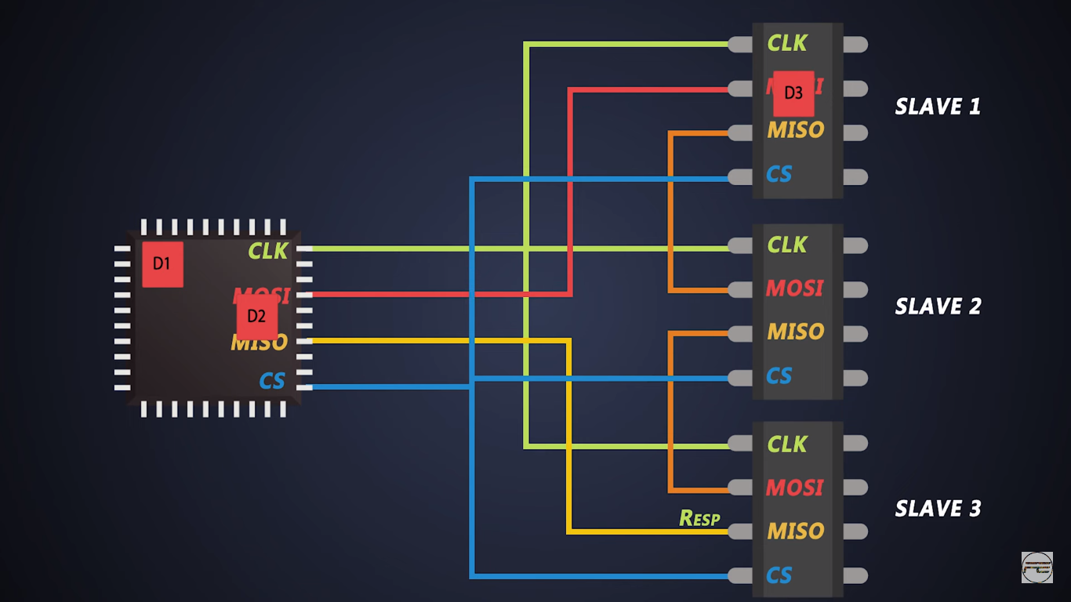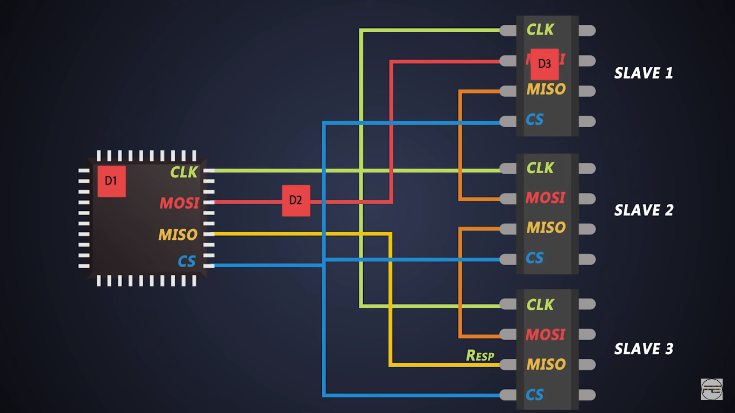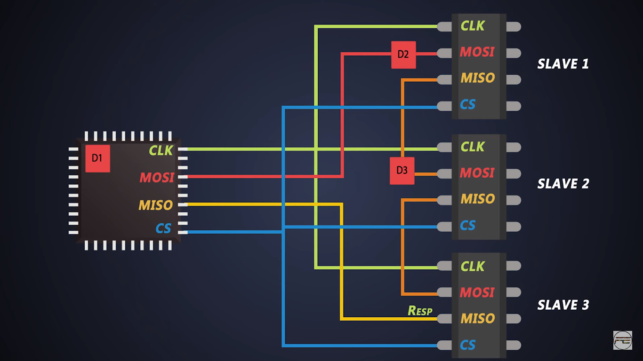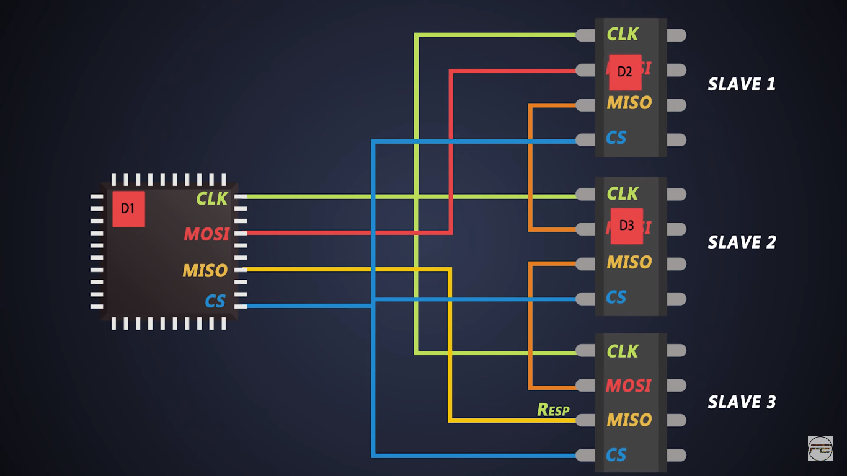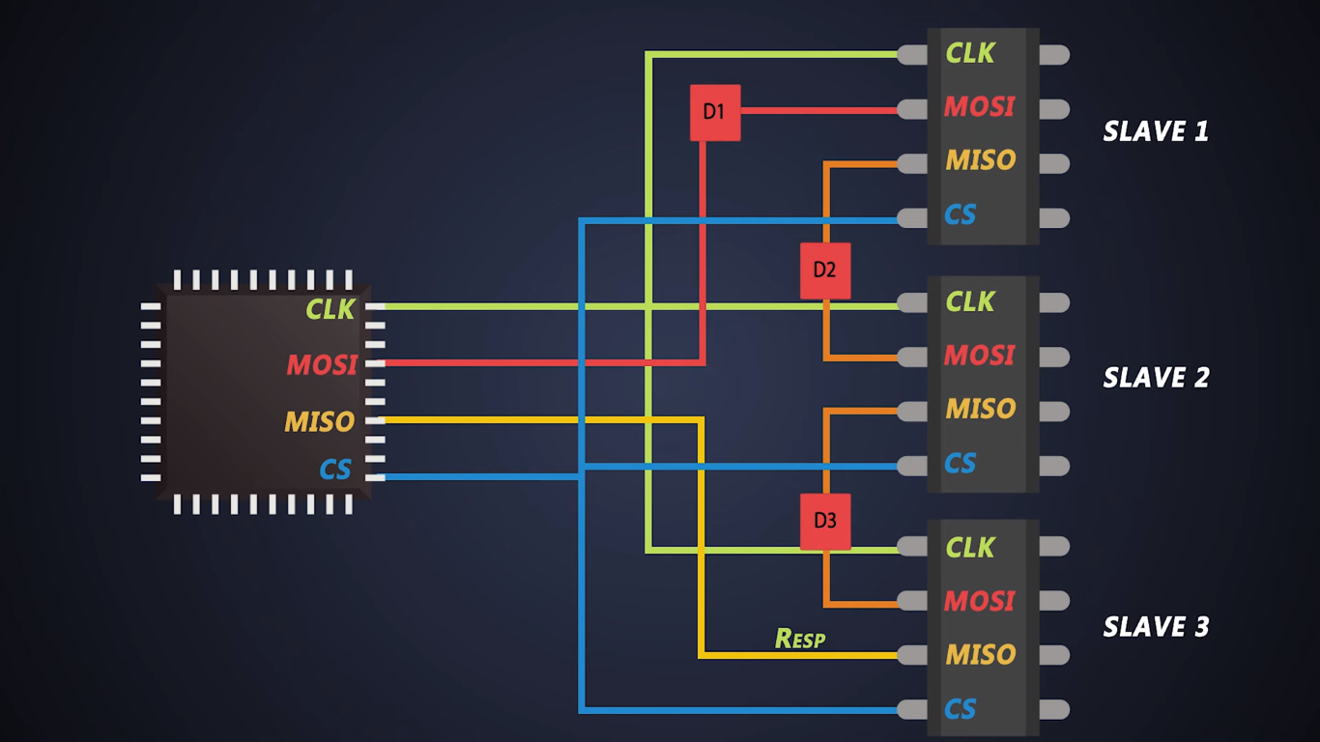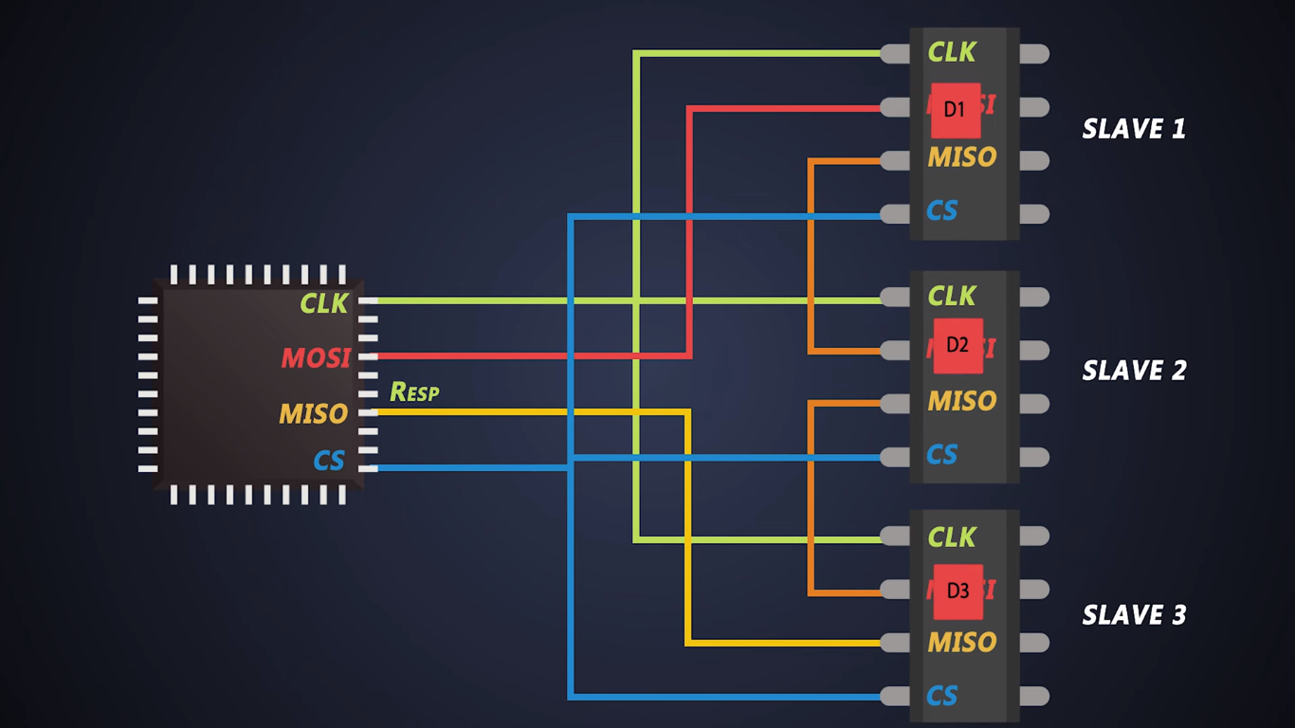

**Advantages of SPI communication**

1. **It has low power consumption compared to I2C protocol as there is no need of pull up resistors and SPI uses clock gating**

* Example: we know that the I2C communication requires pull up resistors to create the 3.3 volt or 5-volt idle state. If a device needs to talk it will pull the SDL line or clock line to low high continuously to send the data . The value of these pull up resistors is in kilo ohms but as we increases the data transmission speed this value decreases .For example we need 2kohm resistance for 400Kbps and this value decreases further for higher speeds. So depending on the pull up resistor value the circuit draws much current which eventually result in power loss.

But the SPI communication is much simpler because there are no pull up needed. The only power requirement is it consumes dynamic power from switching internal transistors and input output lines

* SPI uses clock gating . In synchronous communication we use clock signals and these are the great source of power dissipation because of its high frequency and load. While clock signals do not perform any computation and they are used for my synchronization